Assignment -2

1.Player Skill

Code:

**package** Com.cg.player;

**import** java.util.*;

**class** Player {

**private** String name;

**private** String country;

**private** Skill skill;

**public** Player(String name, String country, Skill skill) {

//super();

**this**.name = name;

**this**.country = country;

**this**.skill = **new** Skill();

**this**.skill = skill;

}

**public** String getName() {

**return** name;

}

**public** String getCountry() {

**return** country;

}

**public** Skill getSkill() {

**return** skill;

}

**public** **void** setName(String name) {

**this**.name = name;

}

**public** **void** setCountry(String country) {

**this**.country = country;

}

**public** **void** setSkill(Skill skill) {

**this**.skill = skill;

}

**public** String toString() {

String str;

str = (String) String.*format*("%-15s %-15s %-15s", **this**.name, **this**.country, **this**.skill.getSkillName());

**return** str;

}

}

**class** Skill {

**private** String skillName;

**public** String getSkillName() {

**return** skillName;

}

**public** **void** setSkillName(String skillName) {

**this**.skillName = skillName;

}

}

**class** PlayerBo {

**public** **void** viewDetails(Player[] playerList) {

System.***out***.format("%-15s %-15s %-15s", "Player", "Country", "Skills");

System.***out***.println();

**for**(**int** i=0; i<playerList.length; i++) {

System.***out***.println(playerList[i].toString());

System.***out***.println("\n");

}

}

**public** **void** printPlayerDetailsWithSkill(Player[] playerList, String skill) {

**int** flag= 0;

Formatter formatter= **new** Formatter();

formatter.format("%15s %15s %15s\n", "Player", "Country", "Skill");

**for**(Player player: playerList)

{**if**((player.getSkill()).getSkillName().equals(skill))

{flag= 1;formatter.format("%15s %15s %15s\n", player.getName(),

player.getCountry() , player.getSkill().getSkillName()); }}

System.***out***.println(formatter);

**if**(flag== 0)

{System.***out***.println("Skill not found");}}

// **TODO** Auto-generated method stub

}

Playermain.java

**package** Com.cg.player;

**import** java.util.*;

**public** **class** Playermain {

**public** **static** **void** main(String[] args) {

Scanner sc = **new** Scanner(System.***in***);

System.***out***.println("Enter the number of player you want to create: ");

**int** n = sc.nextInt();

Player[] p1 = **new** Player[n];

Skill[] s1 = **new** Skill[n];

PlayerBo pB = **new** PlayerBo();

String name, country, skill;

**for**(**int** i=0;i<n;i++) {

System.***out***.println("Enter the player " +(i+1)+ " details");

System.***out***.println("Enter the player name: ");

name = sc.next();

System.***out***.println("Enter Country name: ");

country = sc.next();

System.***out***.println("Enter skill name: ");

skill = sc.next();

s1[i] = **new** Skill();

s1[i].setSkillName(skill);

p1[i] = **new** Player(name, country, s1[i]);

// System.out.println(name + country + skill + " \n");

}

//pB.viewDetails(p1);

**int** ch;

**do** {

System.***out***.println("Menu: ");

System.***out***.println("1. View Details\n 2. Filter players with skill\n 3.Exit");

System.***out***.print("Enter your choice: ");

ch = sc.nextInt();

**switch**(ch) {

**case** 1:

pB.viewDetails(p1);

**break**;

**case** 2:

System.***out***.println("Enter the skill: ");

String sk = sc.next();

pB.printPlayerDetailsWithSkill(p1, sk);

**break**;

}

}

**while**(ch != 3);

}

}

Output:

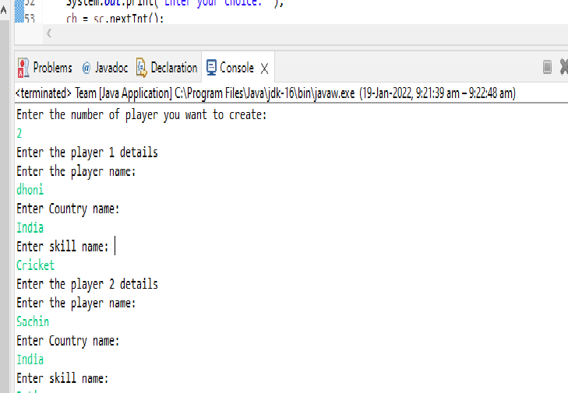

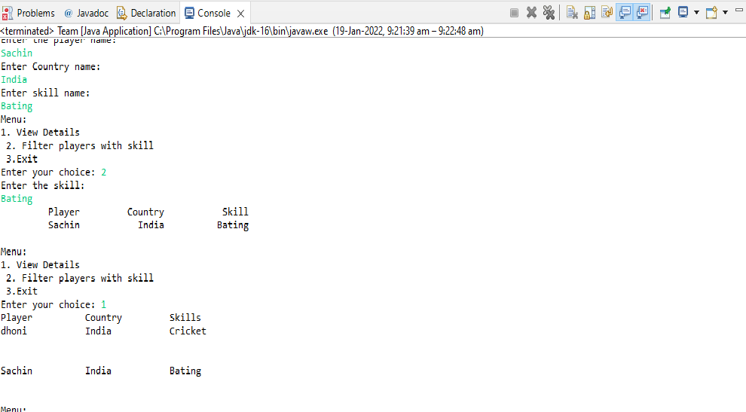

2.Delivery

Code:

**package** Com.cg.innings;

**import** java.util.*;

**public** **class** Innings {

String delivery[];

String inning[];

String result;

String str;

**int** n ;**int** m;**int** a;

String[] split1;

**void** inning()

{

Scanner s = **new** Scanner(System.***in***);

System.***out***.println("Enter number of innings");

n = s.nextInt();

inning = **new** String[n];

**for**(**int** i=0;i<n;i++)

{

Scanner sc = **new** Scanner(System.***in***);

System.***out***.println("Enter innings"+" "+(i+1)+" "+"details");

inning[i]=sc.nextLine();

}

}

**void** delivery()

{

Scanner sc1 = **new** Scanner(System.***in***);

System.***out***.println("Enter number of deliveries");

m = sc1.nextInt();

delivery = **new** String[m];

**for**(**int** j=0;j<m;j++)

{

Scanner sc2 = **new** Scanner(System.***in***);

System.***out***.println("Enter inning"+" "+(j+1)+" "+"details");

delivery[j]=sc2.nextLine();

}

}

**void** result()

{

Scanner sc3 = **new** Scanner(System.***in***);

System.***out***.println("Enter the delivery number for which you need to find the innings number");

a = sc3.nextInt();

str=String.*valueOf*(a);

**for**(**int** k=0;k<m;k++)

{

result = delivery[k];

split1 = result.split(",");

**for**(**int** c=0;c<split1.length;c++)

{

**if**(split1[c].equals(str))

{

System.***out***.println("Innings:"+split1[c+4]);

}

}

}

}

}

**class** DeliveryBo

{

**public** **static** **void** main(String[] args)

{

Innings inningdelivery = **new** Innings();

inningdelivery.inning();

inningdelivery.delivery();

inningdelivery.result();

}

}

Output:

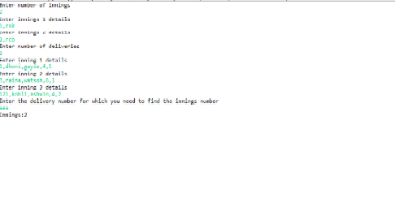

3. Match-Outcome

Code:

**package** Com.cg.match;

**import** java.util.Scanner;

**public** **class** Match {

String matchdate[];

String teamone[];

String teamtwo[];

String venue[];

String status[];

String winnerteam[];

String outcomestatus;

String outcomewinnerteam;

String str1;

String str2;

String result1;

String result2;

**int** n ;

**void** matches()

{

Scanner sc = **new** Scanner(System.***in***);

System.***out***.println("Enter number of matches");

n = sc.nextInt();

matchdate = **new** String[n];

teamone = **new** String[n];

teamtwo = **new** String[n];

venue = **new** String[n];

status = **new** String[n];

winnerteam = **new** String[n];

**for**(**int** i=0;i<n;i++)

{

Scanner sc1 = **new** Scanner(System.***in***);

System.***out***.println("Enter match"+" "+(i+1)+" "+"details");

System.***out***.println("Enter match date");

matchdate[i]=sc1.nextLine();

System.***out***.println("Enter team one");

teamone[i]=sc1.nextLine();

System.***out***.println("Enter team two");

teamtwo[i]=sc1.nextLine();

System.***out***.println("Enter venue");

venue[i]=sc1.nextLine();

System.***out***.println("Enter status");

status[i]=sc1.nextLine();

System.***out***.println("Enter winner team");

winnerteam[i]=sc1.nextLine();

}

}

**void** mdetail()

{

System.***out***.println("Match Details");

String s1=String.*format*("%-15s","Date");

String s2=String.*format*("%-15s","Team One");

String s3=String.*format*("%-15s","Team Two");

String s4=String.*format*("%-15s","Venue");

String s5=String.*format*("%-15s","Status");

String s6=String.*format*("%-15s","Winner");

System.***out***.println(s1+s2+s3+s4+s5+s6);

**for**(**int** j=0;j<n;j++)

{

String s7=String.*format*("%-15s",matchdate[j]);

String s8=String.*format*("%-15s",teamone[j]);

String s9=String.*format*("%-15s",teamtwo[j]);

String s10=String.*format*("%-15s",venue[j]);

String s11=String.*format*("%-15s",status[j]);

String s12=String.*format*("%-15s",winnerteam[j]);

System.***out***.println(s7+s8+s9+s10+s11+s12);

}

}

**void** mdetailos()

{

System.***out***.println("Enter outcome status");

Scanner sc3 = **new** Scanner(System.***in***);

outcomestatus=sc3.nextLine();

str1=outcomestatus.trim();

System.***out***.println("Match Details");

String sos1=String.*format*("%-15s","Date");

String sos2=String.*format*("%-15s","Team1");

String sos3=String.*format*("%-15s","Team2");

String sos4=String.*format*("%-15s","Venue");

String sos5=String.*format*("%-15s","Status");

String sos6=String.*format*("%-15s","Winner");

System.***out***.println(sos1+sos2+sos3+sos4+sos5+sos6);

**for**(**int** d=0;d<status.length;d++)

{

**if**(status[d].equals(str1))

{

String sos7=String.*format*("%-15s",matchdate[d]);

String sos8=String.*format*("%-15s",teamone[d]);

String sos9=String.*format*("%-15s",teamtwo[d]);

String sos10=String.*format*("%-15s",venue[d]);

String sos11=String.*format*("%-15s",status[d]);

String sos12=String.*format*("%-15s",winnerteam[d]);

System.***out***.println(sos7+sos8+sos9+sos10+sos11+sos12);

}

}

}

**void** mdetailowt()

{

System.***out***.println("Enter outcome winner team");

Scanner sc4 = **new** Scanner(System.***in***);

outcomewinnerteam=sc4.nextLine();

str2=outcomewinnerteam.trim();

System.***out***.println("Match Details");

String sowt1=String.*format*("%-15s","Date");

String sowt2=String.*format*("%-15s","Team1");

String sowt3=String.*format*("%-15s","Team2");

String sowt4=String.*format*("%-15s","Venue");

String sowt5=String.*format*("%-15s","Status");

String sowt6=String.*format*("%-15s","Winner");

System.***out***.println(sowt1+sowt2+sowt3+sowt4+sowt5+sowt6);

**for**(**int** e=0;e<winnerteam.length;e++)

{

**if**(winnerteam[e].equals(str2))

{

String sowt7=String.*format*("%-15s",matchdate[e]);

String sowt8=String.*format*("%-15s",teamone[e]);

String sowt9=String.*format*("%-15s",teamtwo[e]);

String sowt10=String.*format*("%-15s",venue[e]);

String sowt11=String.*format*("%-15s",status[e]);

String sowt12=String.*format*("%-15s",winnerteam[e]);

System.***out***.println(sowt7+sowt8+sowt9+sowt10+sowt11+sowt12);

}

}

}

}

Main:

**package** Com.cg.match;

**import** java.util.Scanner;

**public** **class** Main {

**public** **static** **void** main(String[] args)

{

Match matchoutcome = **new** Match();

matchoutcome.matches();

**for**(**int** i=0;i<4;i++)

{

System.***out***.println("Menu:");

System.***out***.println("1.View match details");

System.***out***.println("2.Filter match details with outcome status");

System.***out***.println("3.Filter match details with outcome winner team");

System.***out***.println("4.Exit");

System.***out***.println("Enter your choice");

Scanner sc2 = **new** Scanner(System.***in***);

**int** m=sc2.nextInt();

**switch**(m)

{

**case** 1:

matchoutcome.mdetail();

**break**;

**case** 2:

matchoutcome.mdetailos();

**break**;

**case** 3:

matchoutcome.mdetailowt();

**break**;

**case** 4:

System.*exit*(0);

**break**;

**default**:

System.***out***.println("Invalid Input!");

}

}

}

}

Output:

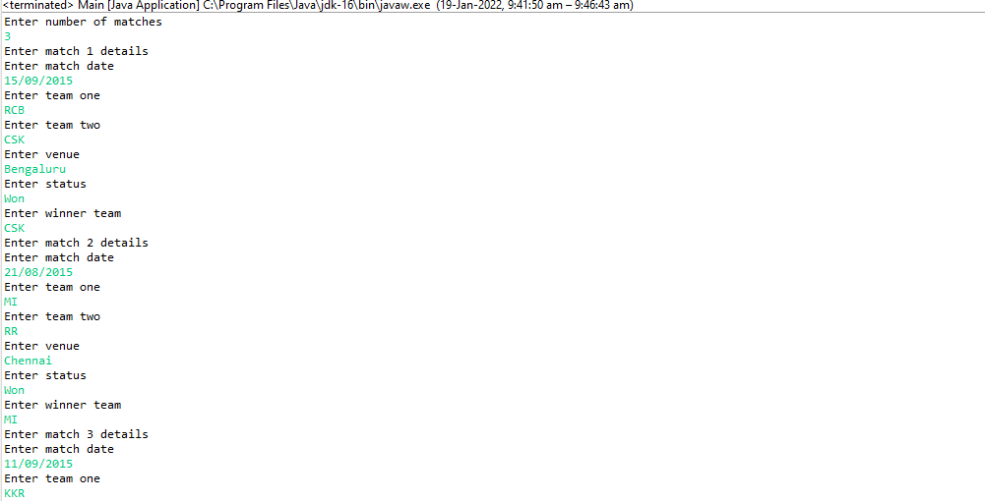

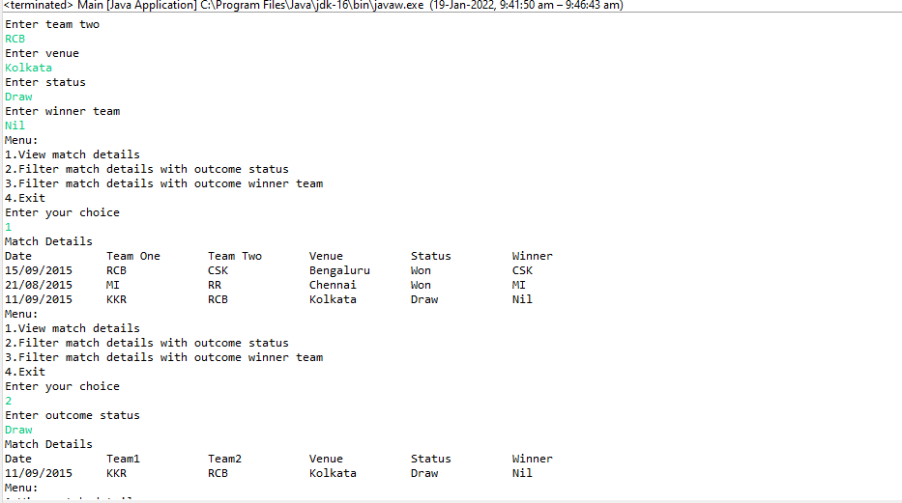

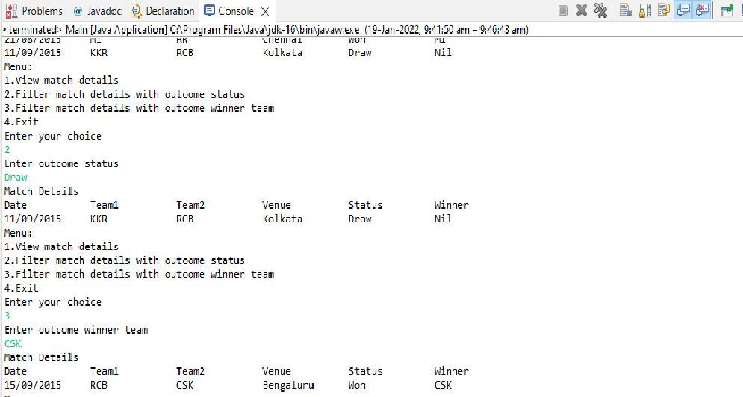

4.Hotel-Room-Cost

Code:

**package** Com.cg.hotel;

**import** java.util.*;

**public** **class** Hotelmanagement {

**public** **static** **void** main(String[] args) {

System.***out***.println("Hotel Tarrif Calculator");

System.***out***.println(" 1.Deluxe Room");

System.***out***.println(" 2.Deluxe AC Room");

System.***out***.println(" 3.Suite AC Room");

Scanner sc = **new** Scanner(System.***in***);

**int** roomType = 0;

String hotelName;

Integer numberOfSqFeet;

System.***out***.println("Select Room Type:");

roomType = sc.nextInt();

System.***out***.println("Hotel Name:");

hotelName = sc.next();

System.***out***.println("Room Square Feet Area:");

numberOfSqFeet = sc.nextInt();

System.***out***.println("Room has TV (yes/no):");

String isTV = sc.next();

Boolean hasTV = **false**;

**if** (isTV.equalsIgnoreCase("yes")) {

hasTV = **true**;

}

System.***out***.println("Room has Wifi (yes/no):");

String isWifi = sc.next();

Boolean hasWifi = **null**;

**if** (isWifi.equalsIgnoreCase("yes")) {

hasWifi = **true**;

}

Integer ratePerSqFeet = **null**;

Hotelmanagement hotelRoomAndCost = **new** Hotelmanagement();

DeluxeRoom deluxeRoom = hotelRoomAndCost.**new** DeluxeRoom(hotelName, numberOfSqFeet, hasTV, hasWifi, ratePerSqFeet);

DeluxeACRoom deluxeACRoom = hotelRoomAndCost.**new** DeluxeACRoom(hotelName, numberOfSqFeet, hasTV, hasWifi, ratePerSqFeet);

SuiteACRoom suiteACRoom = hotelRoomAndCost.**new** SuiteACRoom(hotelName, numberOfSqFeet, hasTV, hasWifi);

**if** (roomType == 1) {

System.***out***.println("Room Tariff per day is: " + deluxeRoom.rate);

}

**if** (roomType == 2) {

System.***out***.println("Room Tariff per day is: " + deluxeACRoom.rate);

}

**if** (roomType == 3) {

System.***out***.println("Room Tariff per day is: " + suiteACRoom.rate);

}

}

**class** HotelRoom {

**protected** String hotelName;

**protected** Integer numberOfSqFeet;

**protected** Boolean hasTV;

**protected** Boolean hasWifi;

**public** String getHotelName() {

**return** hotelName;

}

**public** **void** setHotelName(String hotelName) {

**this**.hotelName = hotelName;

}

**public** Integer getNumberOfSqFeet() {

**return** numberOfSqFeet;

}

**public** **void** setNumberOfSqFeet(Integer numberOfSqFeet) {

**this**.numberOfSqFeet = numberOfSqFeet;

}

**public** Boolean getHasTV() {

**return** hasTV;

}

**public** **void** setHasTV(Boolean hasTV) {

**this**.hasTV = hasTV;

}

**public** Boolean getHasWifi() {

**return** hasWifi;

}

**public** **void** setHasWifi(Boolean hasWifi) {

**this**.hasWifi = hasWifi;

}

**public** HotelRoom(String hotelName, Integer numberOfSqFeet, Boolean hasTV, Boolean hasWifi) {

**super**();

**this**.hotelName = hotelName;

**this**.numberOfSqFeet = numberOfSqFeet;

**this**.hasTV = hasTV;

**this**.hasWifi = hasWifi;

}

**public** **int** calculateTariff() {

**return** **this**.numberOfSqFeet * getRatePerSqFeet();

}

**public** **int** getRatePerSqFeet() {

**return** 0;

}

}

**class** DeluxeRoom **extends** HotelRoom {

**protected** Integer ratePerSqFeet;

**public** DeluxeRoom(String hotelName, Integer numberOfSqFeet, Boolean hasTV, Boolean hasWifi,

Integer ratePerSqFeet) {

**super**(hotelName, numberOfSqFeet, hasTV, hasWifi);

}

**public** **int** getRatePerSqFeet() {

**this**.ratePerSqFeet = 10;

**if** (hasWifi) {

**return** ratePerSqFeet + 2;

} **else** {

**return** ratePerSqFeet;

}

}

**int** rate = **this**.calculateTariff();

}

**class** DeluxeACRoom **extends** DeluxeRoom {

**public** DeluxeACRoom(String hotelName, Integer numberOfSqFeet, Boolean hasTV, Boolean hasWifi,

Integer ratePerSqFeet) {

**super**(hotelName, numberOfSqFeet, hasTV, hasWifi, ratePerSqFeet);

ratePerSqFeet = 12;

}

**int** rate = **this**.calculateTariff();

}

**class** SuiteACRoom **extends** HotelRoom {

**private** Integer ratePerSqFeet;

**public** SuiteACRoom(String hotelName, Integer numberOfSqFeet, Boolean hasTV, Boolean hasWifi) {

**super**(hotelName, numberOfSqFeet, hasTV, hasWifi);

}

**public** **int** getRatePerSqFeet() {

**this**.ratePerSqFeet = 15;

**if** (hasWifi) {

**return** ratePerSqFeet + 2;

} **else** {

**return** ratePerSqFeet;

}

}

**int** rate = **this**.calculateTariff();

}

}

Output:

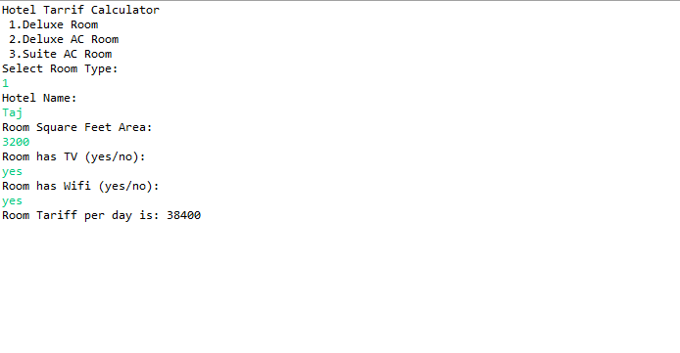

5.TeamMatch

CODE:

package Com.cg.Teammatch;

import java.util.Scanner;

import java.io.*;

import java.util.*;

class Team

{

String player[];

String team[];

String match[];

String result;

String result1;

String[] split;

String[] split1;

String str2;

String str1;

String filter;

int n,m,b;

void Player()

{

Scanner sc = new Scanner(System.in);

System.out.println("Enter player count");

n = sc.nextInt();

player = new String[n];

for(int i=0;i<n;i++)

{

Scanner sc1 = new Scanner(System.in);

System.out.println("Enter player"+" "+(i+1)+" "+"details");

player[i]=sc1.nextLine();

}

}

void Team()

{

Scanner sc2 = new Scanner(System.in);

System.out.println("Enter team count");

m = sc2.nextInt();

team = new String[m];

for(int j=0;j<m;j++)

{

Scanner sc3 = new Scanner(System.in);

System.out.println("Enter team"+" "+(j+1)+" "+"details");

team[j]=sc3.nextLine();

}

}

void Match()

{

Scanner sc4 = new Scanner(System.in);

System.out.println("Enter match count");

b = sc4.nextInt();

match = new String[b];

for(int k=0;k<b;k++)

{

Scanner sc5 = new Scanner(System.in);

System.out.println("Enter match"+" "+(k+1)+" "+"details");

match[k]=sc5.nextLine();

}

}

void findTeam()

{

System.out.println("Menu:");

System.out.println("1)Find Team");

System.out.println("2)Find All Matches in A Specific Venue");

System.out.println("Type 1 or 2");

System.out.println("Enter your choice");

Scanner sc6 = new Scanner(System.in);

int a=sc6.nextInt();

switch (a)

{

case 1:

System.out.println("Enter Match date");

Scanner sc7 = new Scanner(System.in);

String m_date=sc7.nextLine();

str1=m_date.trim();

for(int d=0;d<b;d++)

{

result = match[d];

split = result.split(",");

for(int c=0;c<split.length;c++)

{

if(split[c].equals(str1))

{

System.out.println("Team");

System.out.println(split[c+1]+","+split[c+2]);

}

}

}

System.out.println("Do you want to continue?Type Yes or No");

Scanner sc9 = new Scanner(System.in);

String ans =sc9.nextLine();

if(ans.equals("Yes"))

{

findMatch();

}

else

{

System.exit(0);

}

break;

default:

System.out.println("Invalid Input!");

}

}

void findMatch()

{

System.out.println("Menu:");

System.out.println("1)Find Team");

System.out.println("2)Find All Matches in A Specific Venue");

System.out.println("Type 1 or 2");

System.out.println("Enter your choice");

Scanner sc10 = new Scanner(System.in);

int s=sc10.nextInt();

System.out.println("Match details");

System.out.println("Enter Team Name");

Scanner sc11 = new Scanner(System.in);

String t_name=sc11.nextLine();

str2=t_name.trim();

String s1=String.format("%-15s","Date");

String s2=String.format("%-15s","Teamone");

String s3=String.format("%-15s","Teamtwo");

String s4=String.format("%-15s","Venue");

System.out.println(s1+s2+s3+s4);

for(int e=0;e<b;e++)

{

result1 = match[e];

split1 = result1.split(",");

for(int w=0;w<split.length;w++)

{

if(split1[w+1].equals(str2) || split1[w+2].equals(str2))

{

String s5=String.format("%-15s",split1[w]);

String s6=String.format("%-15s",split1[w+1]);

String s7=String.format("%-15s",split1[w+2]);

String s8=String.format("%-15s",split1[w+3]);

System.out.println(s5+s6+s7+s8);

}

}

}

System.out.println("Do you want to continue?Type Yes or No");

Scanner sc12 = new Scanner(System.in);

String ans1 =sc12.nextLine();

if(ans1.equals("Yes"))

{

findTeam();

}

else

{

System.exit(0);

}

}

}

class MatchBo

{

public static void main(String[] args)

{

Team teammatch = new Team();

teammatch .Player();

teammatch .Team();

teammatch .Match();

teammatch .findTeam();

}

}

Output:

